**REBALL Website**

**From Meeting**

<https://www.elitefootballcoaching.org/>

Hubspot

<https://loveadmin.com/>

***Players can set up their own accounts so we can tailor website features e.g. training options, cue external triggers and fast track booking form***

Flow to Booking

* Players will be prioritised to train with us depending on a combination of whether they’ve trained with us before, their playing level, time to sign up, and reasons for training.
* Log in to account - users can view local training options at different times of season
* Choose course
* Choose 121 or group
* 121: choose training course ( discounted)/single sessions (full price)
* Group: predetermined training course
* Feature maximum number of allowed applicants for each location - anyone else goes straight onto waitlist
* ~~The amount of course applicants, and average prices willing to be paid e.g. like ebay bidding on a product~~
* ~~The price of this x is x. Currently the highest bid sits at x. How much are you willing to pay? -~~ *~~introduce later after traction displaying credibility~~*
* Why do you want to be on the _ course?
* How confident are you out of 10 you can win every 1v1 scenario you face in the game?
* What foot/feet do you want to work on when cutting inside to finish?
* What foot/feet do you want to work on when cutting outside to finish?
* Choose subscription: Training/Training + SISW (desired)/Training + SISW & TAV
* What are all the days and times you are available for a session? - complete availability sheet (group & 121?) - calendly?
* What are all the days and times you are available for a consultation video call? - complete availability sheet

Post acceptance

* Take payments - stripe/paypal
* Training sessions to sync to their preference of calendar
* Automated external triggers sent to players to remind of training slots (turn up at least 15-20 mins before) and new training course launches
* Automated feedback links after each session

Automated Feedback Links After SIS

* At REBALL we care deeply about our reputation for delivering exceptional service. If you wish, please answer a few questions that will take x minutes. All forms are completely anonymous.
* How confident are you out of 10 you can win this scenario in a game?
* What would make this rating higher?
* Do you think this session will help to increase your game success in the scenario and if so why?
* What is your overall impression of the session?
* How would you describe the quality of the coaching?
* How did the training session compare to other training sessions you’ve been a part of?
* How was the customer service?
* What could be changed in the session that would help you improve more?
* What would you change about the session experience?
* Would you use REBALL again in the future and why?
* Are you happy for us to share this feedback as a testimony?

Post Course

* How confident are you out of 10 you can win every 1v1 scenario you face in the game?
* What would make this rating higher?
* Do you think this course will help to increase your 1v1 game success and if so why?
* Have you seen an increase in your 1v1 game success already?
* What is your overall impression of the course?
* How would you describe the quality of the coaching?
* How did the training sessions compare to other training sessions you’ve been a part of?
* How was the customer service?
* What could be changed in the course that would help you improve more?
* What would you change about the course experience?
* Would you use REBALL courses again in the future? If so, why?
* Are you happy for us to share this feedback as a testimony?

Rejection

* Add on waiting list

Account sign up form

* Player’s name:
* Player’s age:
* Parent/guardian name (if under 16):
* Contact email:
* Contact number:
* Postcode:
* Any medical conditions:
* What position are you?
* What level do you play at? - feature multiple choice for all the customer segments
* Who do you play for? those at professional clubs must provide evidence of contract at club: recent social media post/training or match photos or videos/proof of contract/ID card/line-ups/statistics
* Why are you creating a REBALL account?
* How did you hear about REBALL?
* What post training snacks do you use?
* What post training drinks do you use?
* Are you happy for us to post your session highlight reel on our social media?

Consultation questions - these answers need to be added to the player’s profile on the website following consultation call! Or can we already feature this section on the player’s profile waiting to be completed? - DON’T WORRY ABOUT THIS FOR WEBSITE

* Introduce yourself - coaching background and REBALL’S philosophy as in player pitch
* Course objective: to instantly increase game success of all the 8 1v1 scenarios you face in the game. Each session we focus on a new scenario, and go through the tactical, movement and technical information you need to instantly increase your game success.
* Where are you from?
* Who do you support?
* What does your ideal football career look like?
* What kind of player do you want to be remembered as?
* Do you have any players you admire or look up to? If so, why?
* Do you have any coaches you admire or look up to? If so, why?
* What’s your journey been so far in football?
* What are your short-term goals in football?
* What are your long-term goals in football?
* Where do you see yourself in football in the next 1-5 years?
* Where do you see yourself in football in the next 5-10 years?
* What steps are you currently taking to reach your football aspirations?
* What do you think is holding you back from reaching your full potential?
* Are there any other aspects of your game that you feel need improvement?
* What type of training or development have you been focusing on lately?
* Have you worked with any other individual development coaches before? If so, what did you like or dislike about them?
* Psychological screening:
* Do you have any concerns or hesitations about signing up for a course like this?
* Have you faced any significant challenges or setbacks in your football journey? How did you overcome them?
* What motivates you to keep improving?
* How do you handle high-pressure situations, such as crucial matches?
* Have you ever struggled with self-doubt in football? How do you manage it?
* How do you respond to constructive criticism from coaches or teammates?
* Our focus is to create standout players on the pitch. We give you the information you need to instantly increase your game success. But we need you to adopt and train the mindset to become the standout player on the pitch.
* Introduce our psychological principles and send over - we want them to focus on adopting these principles.

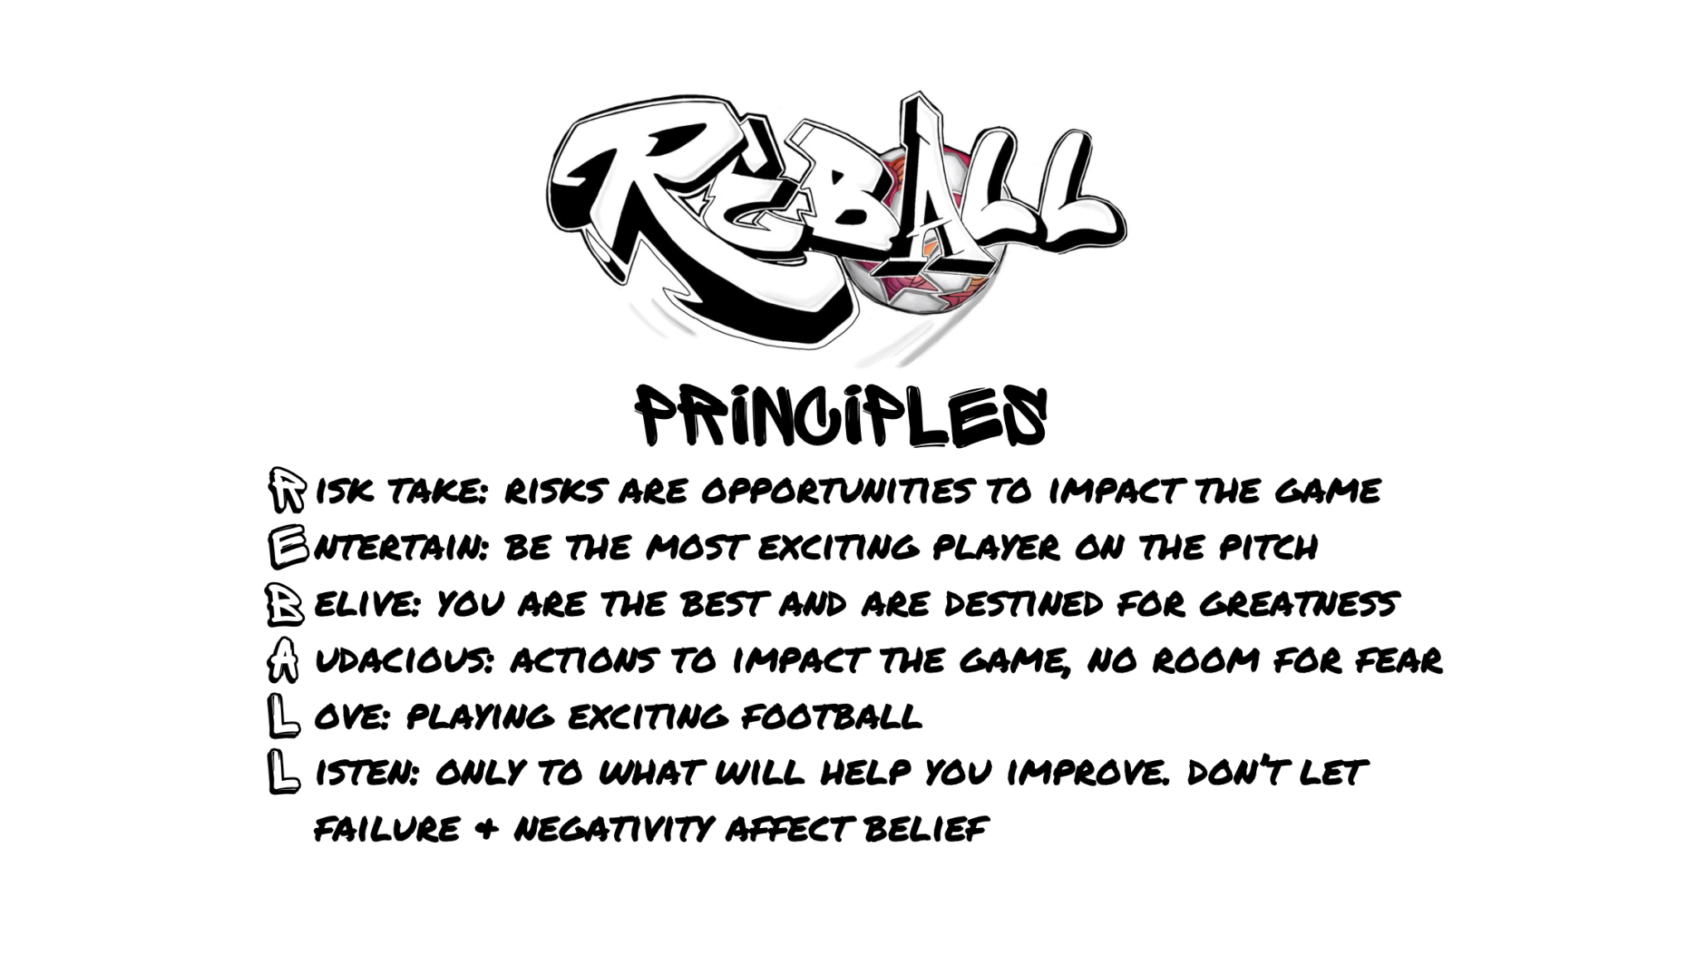

* **Conclude:** wrap up the call by reaffirming your excitement about the possibility of working together. Let them know you’re available for any follow-up questions or additional details.

Other Features

* Cancellation policy
* Business information: service and philosophy

### **Homepage**

1. **Hero Section**:
   * High-quality, dynamic images or videos of training sessions.
   * A powerful tagline or mission statement (e.g.,"increase your game success”/”join the REBALLution”).
   * Call-to-action (CTA) buttons like "Sign up” or "Learn More."
2. **Highlights of the Service**:
   * Key benefits of the program (e.g., USP’s).
   * Testimonials or success stories.
3. **Quick Access Links**:
   * Links to what we offer for each customer persona (they have to sign up to see local options.

### **About Us**

1. **Mission & Vision & USP’s**:
   * What sets the service apart (e.g., dedication to player growth, focus on professionalism, unique methodologies).
2. **Expert Team**:
   * Profiles of coaches and staff with REBALL training and experience.
   * Links to individual bios or achievements.

### **Programs & Services**

1. **Detailed Offerings for each Customer Persona**:
   * Individual training & subscriptions
   * Small group sessions & subscriptions
   * User experience

### **Testimonials & Success Stories**

1. **Player Achievements**:
   * Stories of players who advanced to higher leagues, scholarships, or professional teams.
   * Before-and-after comparisons or interviews.
   * Feature qualitative player and coach research from interventions
2. **Parent Feedback**:
   * Testimonials from parents praising the service and outcomes.
3. **Video Reviews**:
   * Video testimonials from players and parents for an authentic touch.
   * Feature qualitative player and coach research from interventions

### **Booking & Pricing - all featured through login portal**

1. **Online Scheduling**:
   * Easy-to-use booking platform
2. **Pricing Details**:
   * Pricing and booking for 121’s and small group sessions
   * Subscriptions
   * This will need to be a parent/guardian account for under 16’s
3. **Free Trials or Assessments**:
   * Option to book a free introductory session? Or is this just for the target audience? Or free consultation?

### **Player Resources**

1. **Player Development Tracker**:
   * Log-in feature for players to access their training history, SISW, TAV and highlight reels.
2. **Event Updates**:
   * Calendars for upcoming courses.

### **Gallery**

1. **Photos & Videos**:
   * Action shots from training sessions, games, or events.
   * Social media content

### **FAQs**

1. **Common Questions**:
   * "What is the typical player-to-coach ratio?"

### **Contact Us**

1. **Contact Form**:
   * Name, email, phone number, and message fields.
2. **Direct Info**:
   * Phone number, and email address.
3. **Google Map Integration**:
   * Show the location of the training facility options.

### **Additional Features**

1. **Social Media Integration**:
   * Links to active platforms with engaging content.

**To be reintroduced later**

**External Triggers to - the sign-up periods will only be applicable for small group sessions - or do we just leave it and state players will be prioritsed depending on..**

Official REBALL’s - exclusive booking privileges

* These are players who have completed full courses
* Future exclusive deals with affiliations
* Priority-priority access - book on straight away to any course
* They will be notified of REBALL only sign ups 48 hours before entries go on sale.

Member’s (desired target market) exclusive booking privileges

* Desired target market – players who play in professional football clubs
* These players can sign up to be a member by providing evidence of contract at club: social media post/training or match photos or videos/proof of contract/ID card/line-ups/statistics
* They will be notified of members only sign ups 24 hours before entries go on sale
* After this they will have to purchase like everyone else.

Members (not in desired target market)

* They can register in non-priority times only.
* They will not have priority access.
* Anyone not selected will be added to the waiting list